North Mac High School Success Stories

  - Issue Date

Juniors 2017

This year’s high school Olympiad team consisted of four students from each grade level. Thirty-two teams participated from surrounding schools. During the competition, participants were challenged to several tasks. The challenges included problem solving, logic skills, time-management and teamwork.

Students constructed the longest span using only masking tape, a file folder, and a Popsicle stick. Their span had to hold a bowl of water while one team member laid underneath. Students also constructed a rocket using a file folder, masking tape, a tissue, and a note card. One of the most popular challenges was the relay race. Students multitasked all the while completing an analogy worksheet and building a tower from paper that would hold blocks.

North Mac was represented well by 16 of our top students.

Juniors: 4th place Overall
Received medals and a plaque
Cole Kallenbach
Bryce Trojcak
Jonah Cassens
Audrey Hannah

Gifted Olympiad
By Abbi Barton

New Construction
Cole Kallenbach laid underneath his teams constructed project and avoided getting water spilled onto him. The juniors won this event.
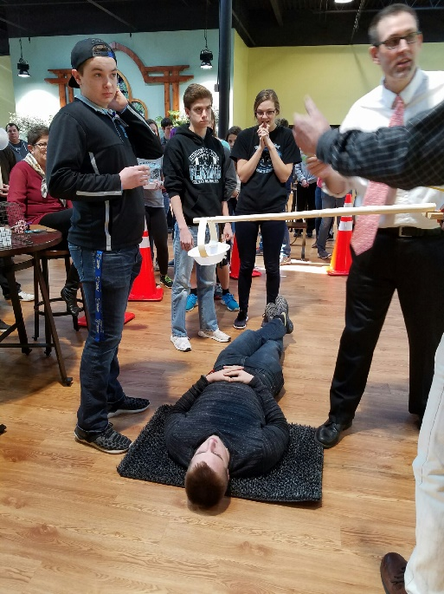

School Improvement Goals
Building level goals are written/created by teachers, principals, dean of students, and the superintendent.

High School Math Goal:

By Rob Horn

One of Illinois’s required courses for high school graduation is Algebra I. We at North Mac decided that one of our math department goals this year would focus on the freshmen/sophomore level population of students in mathematics.
The goal process began as our three high school math teachers (Mrs. Orisek, Ms. Humphreys, and Mrs. Gillespie) began having department meetings. We knew that our students were required to pass Algebra I and we wanted to minimize the number of students who did not. The discussion process began about the growth of our math students back in August 2016. We, as educators, wanted to ensure growth was occurring in all math courses and especially in Algebra I.
At the beginning of the school year, our math department met to plan goals for the school year. During this process, a goal was written for Algebra I students stating, “when looking at the beginning of year and middle of year assessment results, we will compare all students enrolled in Algebra I and expect them to show a growth of 5%”. Some of the strategies our teacher’s implemented to ensure we achieve this goal was to write a standardized assessment and implement them twice a semester. Data will be collected, reviewed, and discussed at math department meetings throughout the semester to gauge whether or not we were on pace to attainment. In the attempt to avoid that chance of students not participating throughout the semester with their homework, time will be provided in class to allow homework to be started prior to dismissing each day. This would provide an opportunity for students to utilize the highly qualified staff for individual support prior to leaving for the day.
As a result, first semester results showed that 100% of our Algebra I students showed at least 5% growth. Not only did they meet this goal, they surpassed it. The goal attainment of this population of students ranged from 100% of the students showing 29% growth to 82% growth. The average growth within this population was 55%.
Moving forward, our math teachers will continue this process into the second semester and begin taking observations of improvement for next school year. Changes to the assessment tools will be re-submitted to the PERA committee for final approval. After reviewing classroom assessments procedures, adjustments within the classroom will occur. Student data will be examined, both on a whole class basis as well as on an individual basis.

