Technology Standards Articulation by Grade
Fourth Grade

STRAND 1: Basic Computer Operations and Concepts

Every student will understand the operation and function of current technology and become proficient in its use.
Concept 1: Communicate about technology using appropriate and accurate terminology.
Students will:

B 1. Identify and use basic computer components, including input and output devices (e.g. mouse, monitor, keyboard, storage devices, cursor, printer, headphones, microphone, digital camera, USB drive)

B 2. Use basic appropriate technology vocabulary (e.g. desktop, monitor, keyboard, mouse, start, logoff, print, click and double-click, backspace, delete, maximize, minimize, icons, taskbar, open and close)

B 3. Use applications, folders, hard drive, recycle bin, network folder, document icons

B 4. Recognize the purpose of basic file menu options (e.g. new, open, save, save as, quit, exit, print, print preview, undo, and redo etc.)

Concept 2: Computer Access
Students will:

B 1. Power on/power off computer

B 2. Login/logout of computer/network

B 3. Demonstrate proper use/handling of computer drives and peripherals

B 4. Open and quit an application

Concept 3: Input Devices
Students will:

B 1. Navigate with a pointing device (e.g. use of drop down menus, use of vertical and horizontal scrolling, ability to choose options within a program)

B 2. Use left-click mouse function

B 3. Use double-click mouse function

B 4. Use right-click mouse function

Concept 4: Computer Navigation
Students will:

B 1. Locate, launch and exit software applications using icons or shortcuts that are appropriate for the designed task (e.g. local and network)

Technology Standards Articulation
Fourth Grade

B 2. Use file management to create, locate and save files from local and network drives

B 3. Perform simple editing functions (e.g. copy, paste, spell check, and paragraph setup)

B 4. Navigate using browser, address bar, refresh, forward, back, URL, stop, home, search, link, etc.

B 5. Open and use multiple programs, windows, and/or browser tools simultaneously

Concept 5: Output Devices
Students will:

B 1. Print independently choosing printer, (e.g. local, network, color, etc.), quality, number of pages, format

Concept 6: Media Resources
Students will:

B 1. Operate interactive white board

B 2. Operate a digital camera

Concept 7: Troubleshoot Systems and Applications
Students will:

B 1. Apply strategies for identifying and solving routine frozen screens that occur in everyday use

B 2. Select technology tools and software to solve problems

B 3. Perform undo/redo function

B 4. Use guess and check strategies

11/12/2011 2

Technology Standards Articulation
Fourth Grade

STRAND 2: Digital Citizenship

Students understand human, cultural and societal issues related to technology and practice legal, ethical and moral behavior.
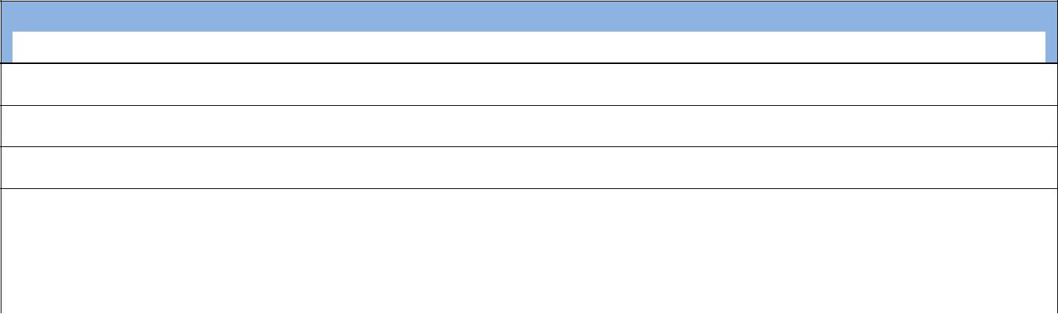
Concept 1: Develop Positive Technology-Related Behaviors and Attitudes
Students will:

B 1. Follow directions when using computers and peripherals

B 2. Work collaboratively with others

B 3. Assist others when needed

B 4. Complete tasks as assigned

B 5. Respect the rights of others

B 6. Recognize how technology is used in today’s world

Concept 2: Acceptable Use
Students will:

B 1. Use school network and Internet ethically and appropriately

B 2. Demonstrate ethical behaviors when using technology (e.g. Internet, Cell Phone)

B 3. Handle external media carefully (e.g.cd, dvd etc...)

B 4. Demonstrate correct and responsible use and care of technology

B 5. Follow school’s Acceptable Use Policy (AUP) and know the consequences of noncompliance

B 6. Understand and abide by laws and penalties, pertaining to copyright and intellectual property including duplication of text and audio files

B 7. Understand the ethical implications of plagiarism and avoid its use

Concept 3: Internet Personal Safety
Students will:

B 1. Recognize and understand responsible cyber-community citizenship (e.g. Club Penguin and Webkinz, or similar websites)

B 2. Understand and practice responsible use of personal safety (e.g. password, personal and family information)

B 3. Recognize and understand the use of technology as a way to communicate with others and access information for learning

B 4. Understand proper netiquette when communicating with others online

B 5. Practice positive attitudes and understand how cyber-bullying affects others

11/12/2011 3

Technology Standards Articulation
Fourth Grade

STRAND 3: Technology Tools that Promote Creativity and Innovation

Every student will demonstrate creative thinking, construct knowledge and develop innovative products and processes using technology.

Concept 1: Experience a variety of software and online applications to complete innovative products and processes.
Students will:

B 1. Use appropriate software application(s) to complete tasks (e.g. Kid Pix, Power Point, Paint, Word Processing)

B 2. Experiment with various types of multimedia resources to help complete curriculum tasks (e.g. text, color, design, transitions, animation, audio/sound, video, etc.)

B 3. Illustrate knowledge and understanding of curriculum using animation, photo-editing, word processing, spreadsheet, or multimedia software.

Concept 2: Keyboarding
Students will:

B 1. Locate, identify and use A-Z and 0-9 keys

B 2. Locate special keys (e.g. enter, spacebar, escape, tab key, arrow keys, home key, shift, caps lock, num lock, delete and backspace keys)

B 3. Locate and utilize keyboard shortcuts (e.g. Esc, Ctrl, Alt, Del, and function keys)

B 4. Use correct home row hand positions, fingering and posture

Concept 3: Word Processing
Students will:

B 1. Use basic word processing skills to enhance the writing process

B 2. Use clip art to illustrate concepts and ideas

B 3. Identify, locate and practice terms and concepts related to word processing (e.g. toolbars, alignment, font style, font size, font color, margins, etc.)

B 4. Use word processing skills to format text (e.g. centering, spell check, thesaurus)

B 5. Be able to open, create, delete, copy, paste, save, locate and/or print a file/document

B 6. Be able to import/export a document file or folder

Concept 4: Skill Building with Spreadsheets
Students will:

B 1. Identify and define terms and concepts related to spreadsheets (e.g. sort, row, column, cell address, classify, line-graphics, etc.)

11/12/2011 4

Technology Standards Articulation
Fourth Grade

B 2. Be able to enter data into cells of spreadsheet program and perform simple calculations

B 3. Be able to create a spreadsheet and display results in a graph using given data
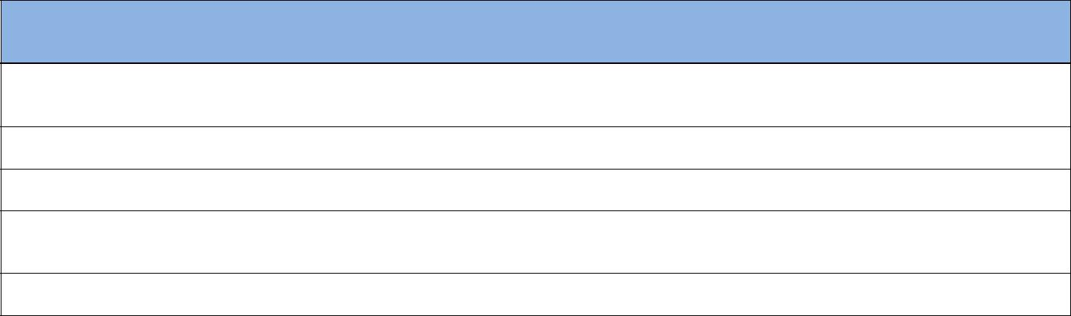

Concept 5: Multimedia
Students will:

B 1. Identify and define terms and concepts related to multimedia (e.g. transition, slides and graphics)

B 2. Utilize draw / paint software, to create original works

B 3. Locate, import and adjust graphics to enhance original works of self-expression

B 4. Produce a 3-5 page multimedia presentation independently (e.g. text, graphics ,clipart, sound, and transitions)

B 5. Use a variety of peripherals (e.g. digital camera, interactive white board)

Concept 6: Transfer Current Knowledge to Learning of New Technologies
Students will:

B 1. Use concepts and basic skills and apply them to more advanced software.

Concept 7: Skill Building with Desktop Publishing
Students will:

B 1. Use basic desktop publishing skills

B 2. Use digital cameras

B 3. Create a visually appealing presentation that includes a graph, clip art, borders and a variety of fonts

11/12/2011 5

Technology Standards Articulation
Fourth Grade

STRAND 4: Communication & Collaboration

Every student will use productivity tools and will collaborate, publish and interact with peers, experts and other audiences by using telecommunications and media

Concept 1: Communication
Students will:

B 1. Use digital media to gain understanding of cultural differences in a global society with teacher guidance

B 2. Use various digital media to communicate and exchange ideas

B 3. Collect and publish information for peers using digital resources

Concept 2: Collaboration
Students will:

B 1. Collaborate with others using digital media to learn, develop and share information or create a project in a curriculum area

B 2. Use technology tools to exchange stories and information about their lives and local community

B 3. Use digital resources to gain understanding and appreciation of others

B 4. Evaluate ones own work and the work of others.

11/12/2011 6

Technology Standards Articulation
Fourth Grade

STRAND 5: Technology Research Tools

Every student will utilize technology based research tools to locate and collect information pertinent to the task, as well as evaluate and analyze information from a variety of sources.
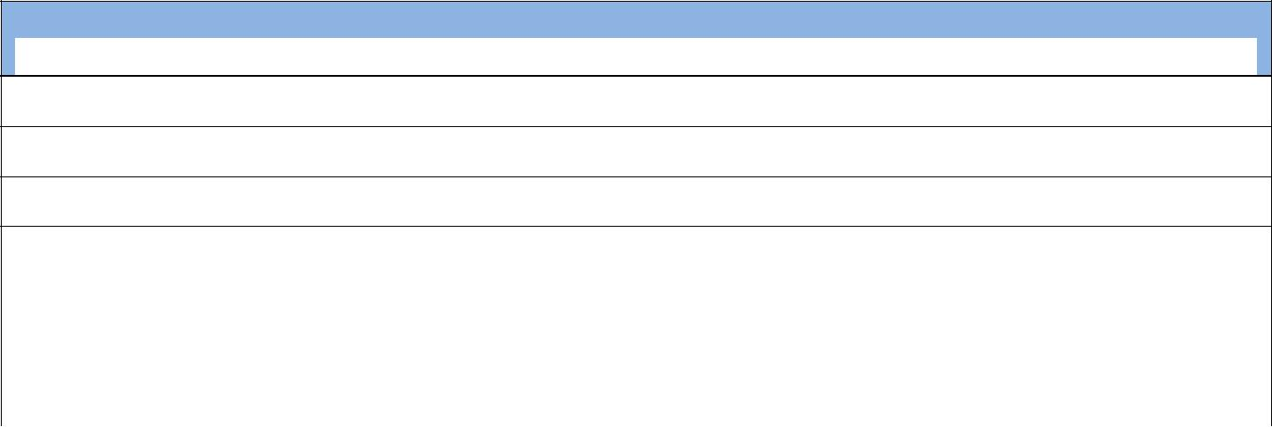
Concept 1: Researching Tools
Students will:

B 1. Access a website that is bookmarked or linked

B 2. Launch a web browser, enter web address and access the information

B 3. Gather information using appropriate internet resources

B 4 Use search engines effectively to locate information

B 5. Locate and analyze technology resources to complete a specific task

B 6 Evaluate the information of Internet reference sources, checking for bias and validity

B 7. Discuss and respect ownership of resources

11/12/2011 7

Technology Standards Articulation
Fourth Grade

STRAND 6: Technological Critical Thinking, Problem Solving, and Decision Making

Every student will use critical thinking skills to plan and conduct research, manage projects, solve problems and make informed decisions using appropriate digital tools and resources.
Concept 1: Critical Thinking
Students will:

B 1. Understand how technology impacts their daily life

B 2. Research a topic and identify a problem, with teacher guidance

Concept 2: Problem Solving
Students will:

B 1. Follow and manage activities to develop a solution or complete a project

B 2. With teacher assistance collect data to identify a problem and find a solution.

B 3. Use spreadsheet tools and/or graphing programs to analyze and symbolize numerical data

Concept 3: Decision Making
Students will:

B 1. Use technology tools and resources provided to address a variety of tasks and problems

B 2. Use multiple processes to explore alternative solutions

B 3. Use technology to analyze information to solve basic problems

11/12/2011 8

