Embed Video into PowerPoint
- Find your video on the Internet or YouTube. 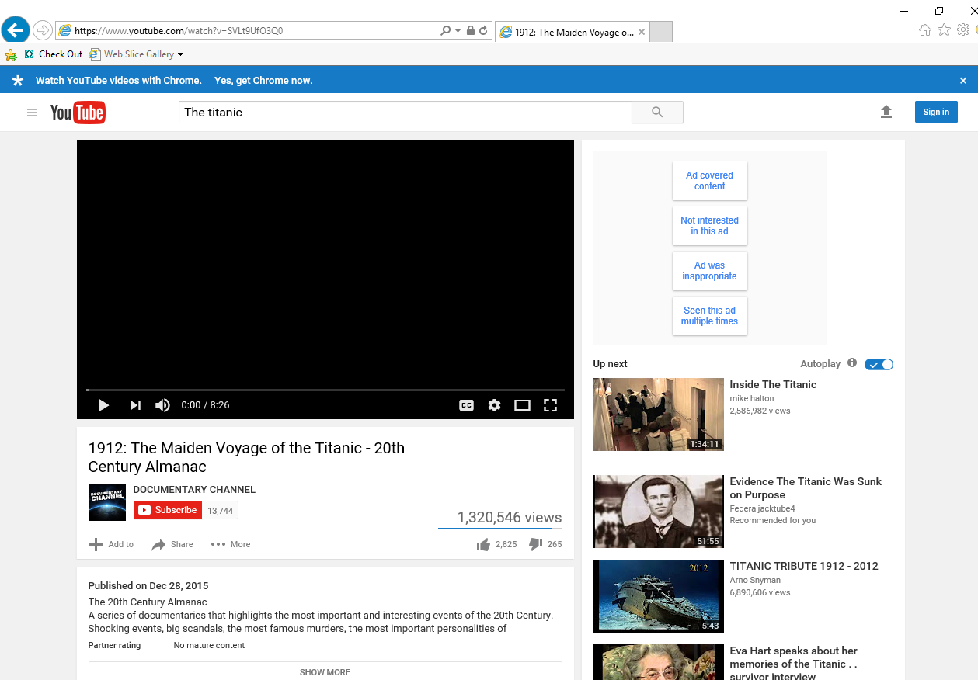
- Click on “Share” and then “Embed” to get the embedding code. 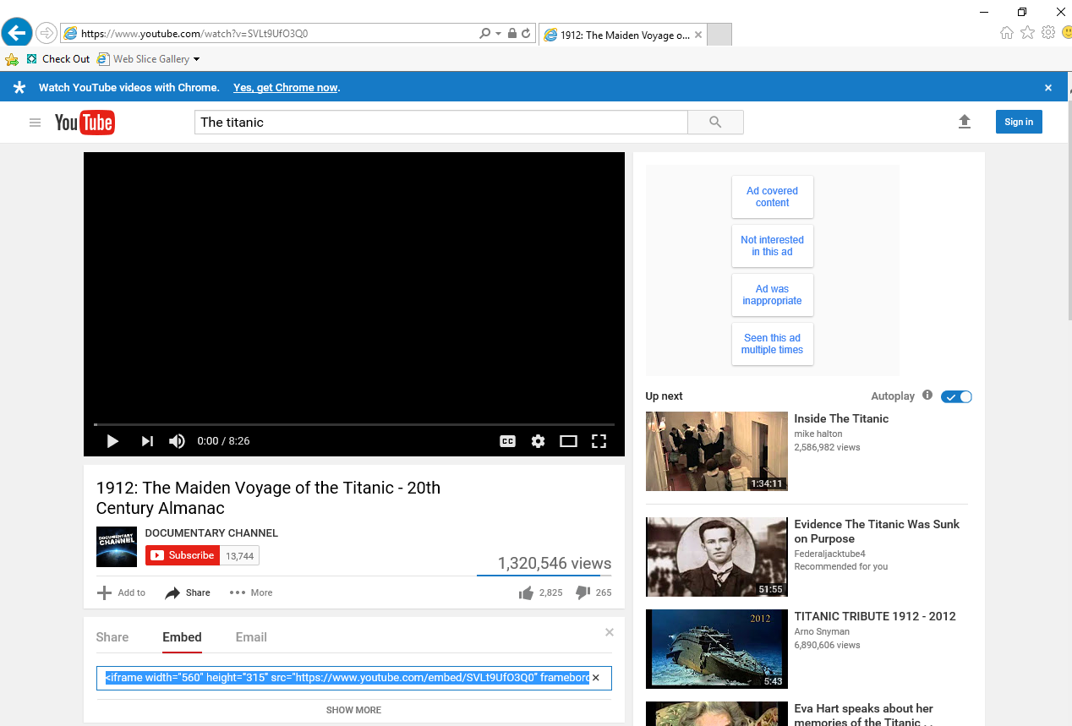
- Right click on the embedding code and click “Copy” 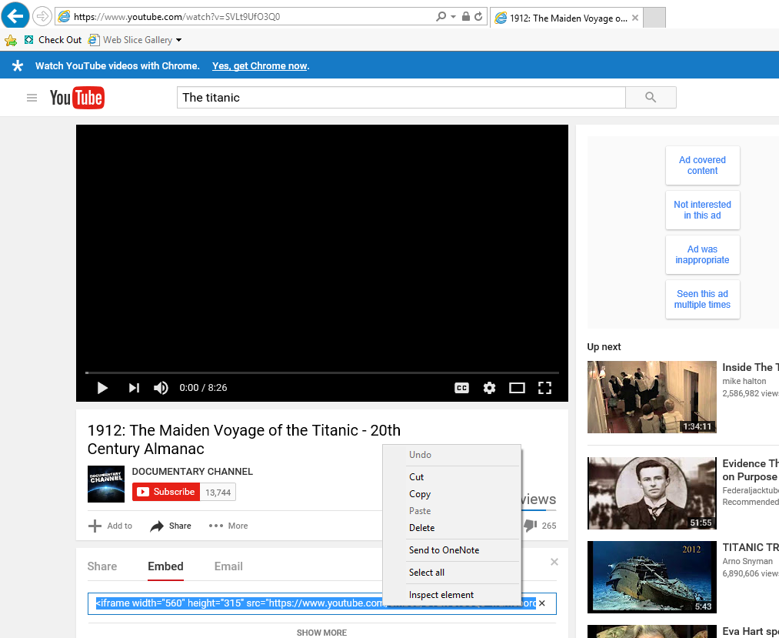
- Go back to PowerPoint and click on the bottom text box where you want to add your video. Then click on the “Insert” tab at the top and “Video” on the right.
|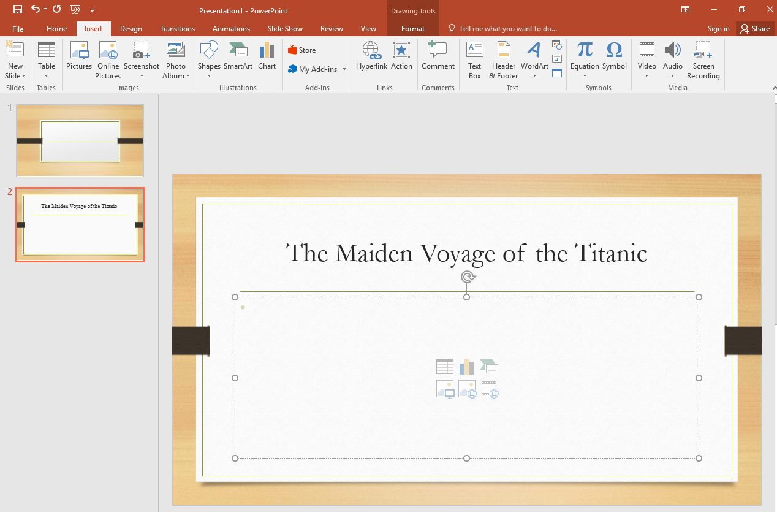
- Select “Online Video” from the drop down menu of “Video” 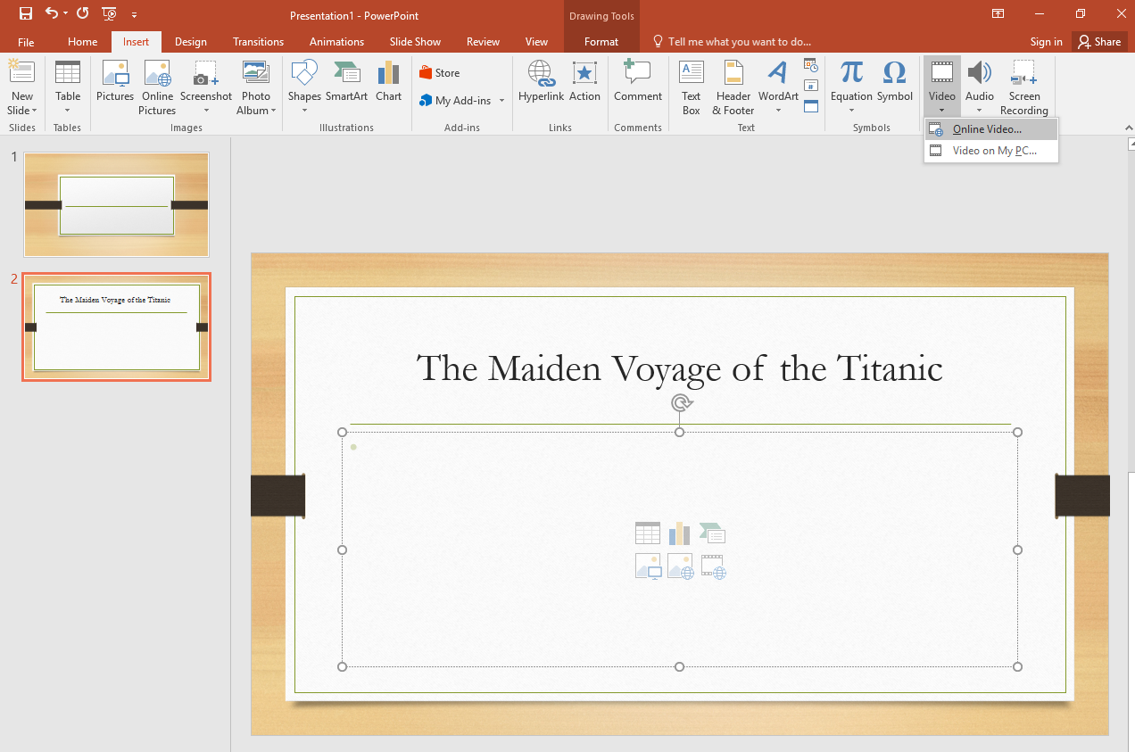
- Right click and Paste your embedded code in the 2nd box labeled “From a Video Embed Code,” then click the right arrow in the box.
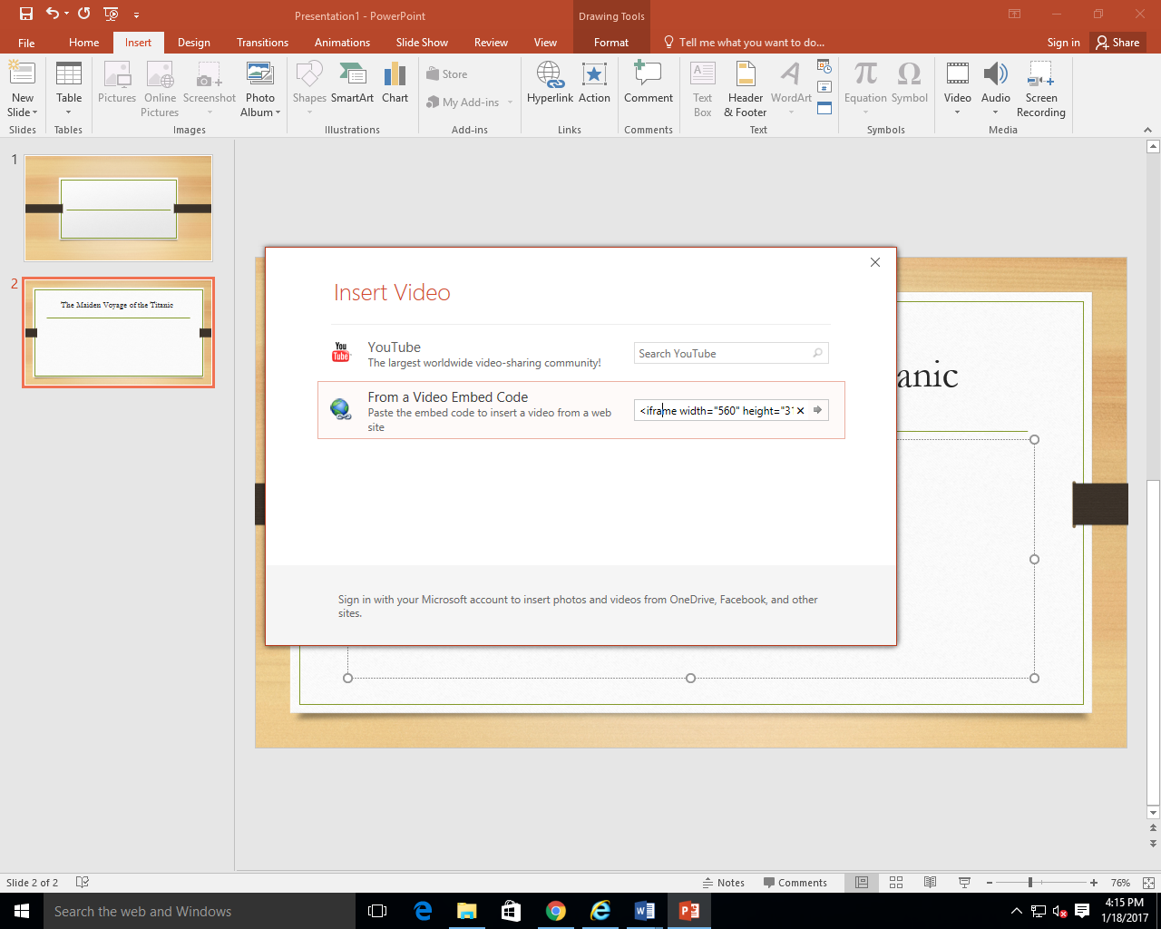
- Your video will appear in the slide after a few seconds (be patient). You can stretch the size using the corners (not the middle circles) to enlarge the video on the slide. 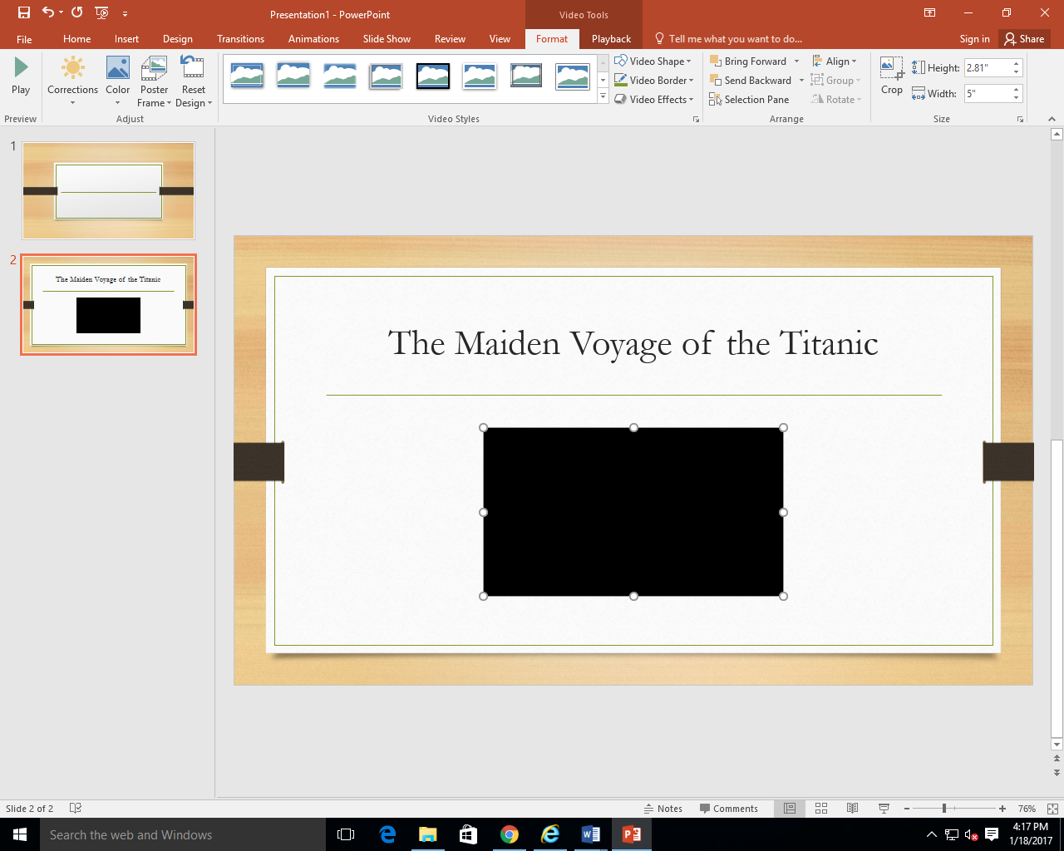
- Test/View the video in presentation mode

