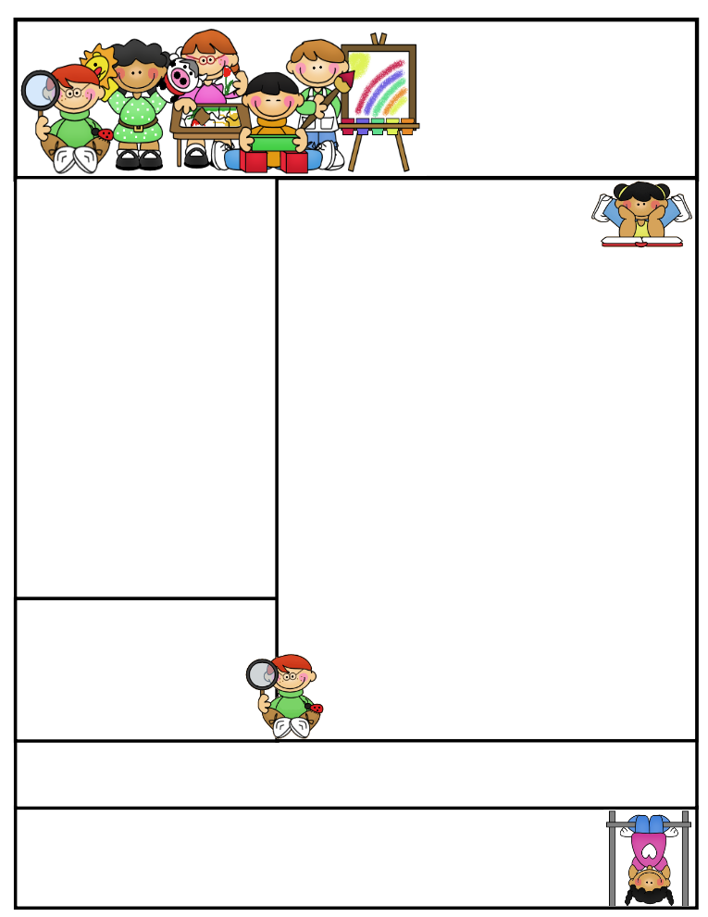

**Teaching Tip** –Try mixing up the addition and subtraction flash cards when practicing at home. This will help your child to recognize the + and – signs.

E

**Classroom News**

This week we will be introducing some new sight words and letter sounds. Please continue to review all sight words. In math we will finish 3D Shapes and then reviewing all math skills including addition and subtraction. **I will no longer send any reading work home.**

I have been assessing students on sight word recognition each week. I will be sending messages through Dojo if your child still has sight words to master or needs to be working on other skills for end of year assessment.

We will be celebrating summer birthdays this month. If your child has a summer birthday and would like to bring in a snack, please Dojo me or send a note. Please remember snacks need to be store bought.

We only have 12 days left in our school year, but we are going to continue to work on all Kindergarten Exit Skills.

**Important Dates**

* **Ma**y **10th** – Field Trip to Henson Robinson Zoo
* **May 16th** – Kindergarten day at the park
* **May 20th** – Fun Day at school
* **May 21st** – Last Day of School/Early dismissal

**Happy May Birthday’s to Michael and Raelynn**



Mrs. Etter

Newsletter

May 6, 2024

**Mrs. Sarah Etter Email address: setter@northmacschools.org  
North Mac Elementary  
231 W. Fortune Street  
217-965-5424**

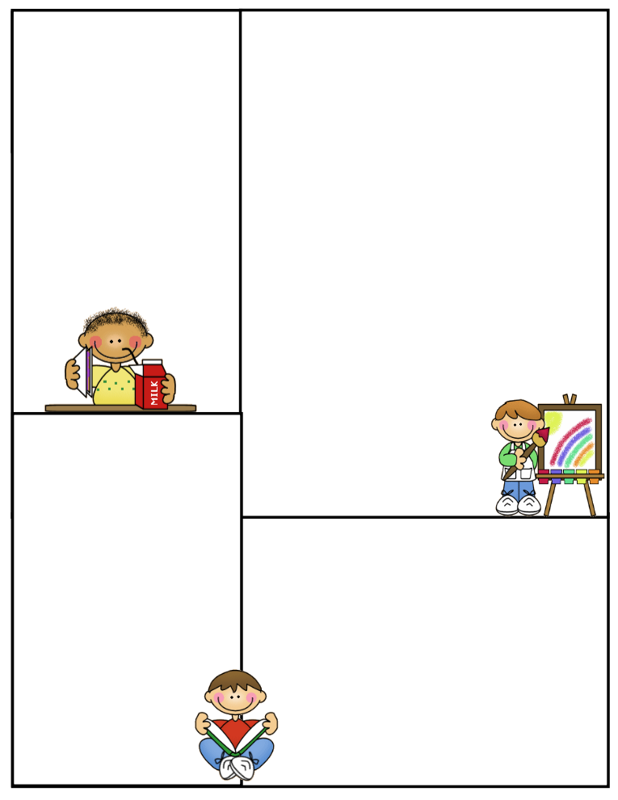

**What We’re Learning**

**Essential Question:** Why is it important to help your friends?

**Alpha Friends: Vv- Vinny Volcano & Zz- Zelda Zebra**

**Phonics:** Letter and sound for Vv and Zz

**Sight Words:** our, day, take, too, show, off

**Phonological Awareness**: I can substitute letters to make new words:

cat - fat, chip – ship, wag - tag

**Math**: Finishing 3-D shapes, then

Reviewing Addition & Subtraction

**Science –**

Don’t forget to send a water bottle with your child each day. The weather is FINALLY getting warmer and students are getting more drinks throughout the day

A to Z Countdown

Monday – O – outdoor Fun

Tuesday – P- Bring in a picture to share

Wednesday- Q – Practice being quiet

Thursday – R – Bring a flashlight to read with

Friday – S – Safari – Trip to the zoo

**Daily Specials**

**0.** **Monday**: P.E @ 1:40 & Music

@ 2:10

**Tuesday**: P.E @1:40 &

Library @ 2:10  
**Wednesday**: P.E @ 8:30

**Thursday**: P.E @ 1:40 & Music

@ 2:10

**Friday:** P.E @ 1:40 & computers @ 2:20