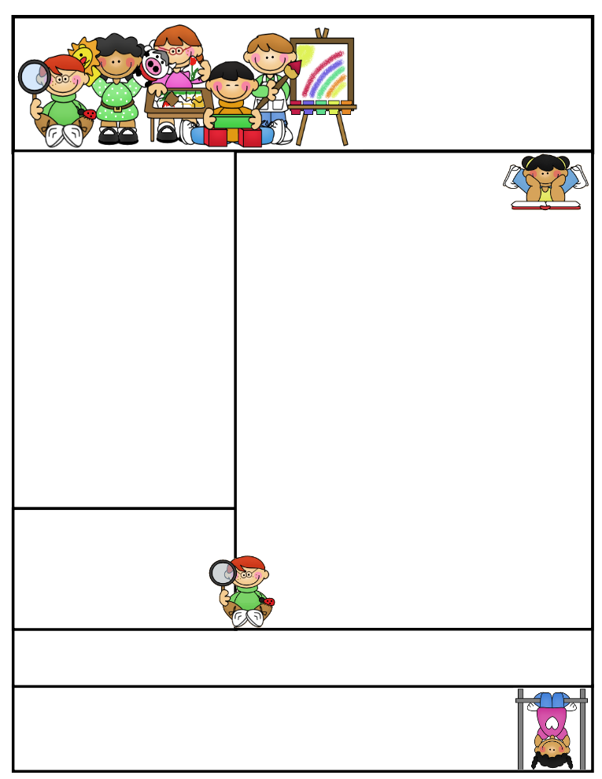

**Teaching Tip** –Try mixing up the addition and subtraction flash cards when practicing at home. This will help your child to recognize the + and – signs.

E

**Classroom News**

It is so much fun counting down through the alphabet the last 26 days of school. I am having just as much fun as the children. I will try to put up daily pictures on DOJO. Please let me know if you did not receive an A-Z calendar of activities. I have it posted on Dojo too.

This week will be working on Unit 6 in Journeys. We will be reviewing blending words, writing, and sight words.

..

**Important Dates**

* **April 25th–**

Reading night

* **Ma**y **10th** – Field Trip to Henson Robinson Zoo
* **May 16th** – Kindergarten fun day at the park

Be sure to send in your child’s folder daily and return their reading envelope with their weekly books by Friday.

Mrs. Etter’s

Newsletter

April 22, 2024

**Mrs. Sarah Etter Email address: setter@northmacschools.org  
North Mac Elementary  
231 W. Fortune Street  
217-965-5424**

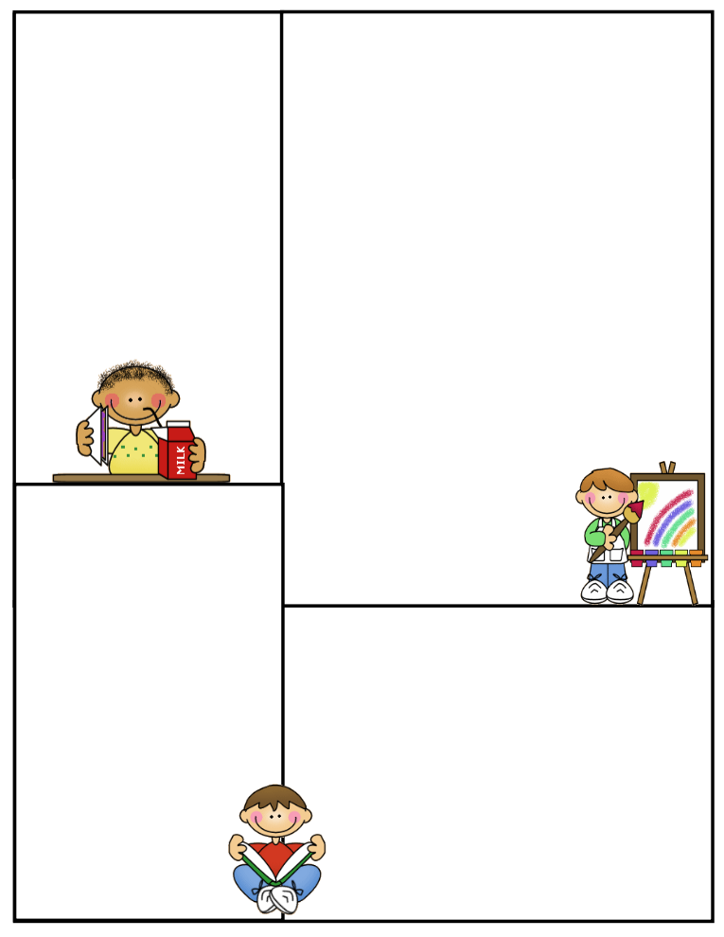

Don’t forget to send a water bottle with your child each day. Water helps hydrate the brain. Also, don’t forget to send a light jacket for your child to wear for outside play. Sometimes it is a little cool when the students go to recess. All children also need to have a pair of tennis shoes to wear in gym class.

**E – I Days**

**E – Extra recess**

**F –Wear your favorite color**

**G – We will chew gum at school**

**H – Wear a hat to school**

**I – Ice pops**



**What We’re Learning**

**Essential Question:** Why is it important to try hard?

**Alpha Friend:** /Uu/

**Phonics:** Letter and sound for short and long /Oo/and /Ee/, then review x/ks/,/Jj/, /Hh/, /Kk/

**Sight Words**: one, every, ask, help

**Phonological Awareness**: I can substitute letters to make new words.

cop-hop dog-dot cat-rat bus- bug

**Math**: What are 2-D and 3-D shapes?

**Science –**

**Daily Specials**

**Monday**: P.E @ 1:40 & Music

@ 2:10

**Tuesday**: P.E @1:40 &

Library @ 2:10  
**Wednesday**: P.E @ 8:30

**Thursday**: P.E @ 1:40 & Music

@ 2:10

**Friday:** P.E @ 1:40 & computers @ 2:20