Mrs. Winslow’s Newsletter
Week of Feb. 27
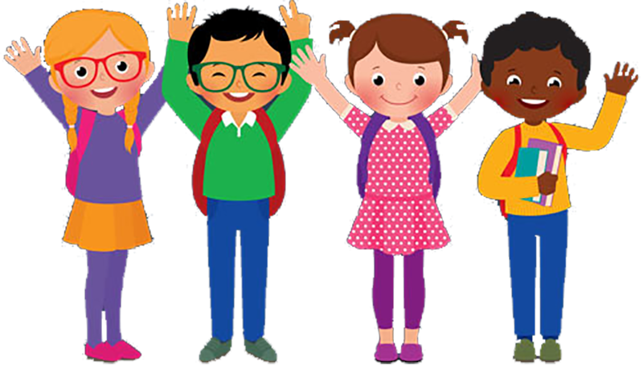

Reading:
Essential Question- Why is it important to learn about people from the past?
Main Story – Thoma’s Rivera
HFW – done, paper, were, great, soon, work, laugh, talk
Phonics – Vowel pairs oa, ow making long o sound – blow, boat
Contractions: I have / I’ve we are / we’re
Writing – Introduction to Informative Writing.
Social Studies– We will read about people from the past who have helped better our world.
Math – We will work on problem solving and using tally, bar, and picture graphs.

